**High Iron Food**

If your Iron level is low, choose these foods more often.

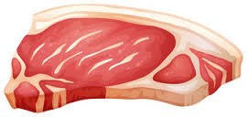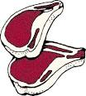

Red meat

pork and poultry

Seafood

Beans

Dark green leafy vegetables

(spinach)

Dried fruit

(raisins and apricots)

Iron-fortified cereals, breads and pastas

Peas.

