A HEALTHY DIET IS AN IMPORTANT PART OF THE TREATMENT OF DIABETES.

A DIET GUIDE FOR DIABETICS

Some general advice to help you in regards to your diet:

* If you are feeling thirsty, quench your thirst with low sugar drinks, such as; Water, Sugar Free Squash, Diet fizzy drinks or tea and coffee without sugar. You can use artificial sweetener.
* Eat regular meals and discuss with your diabetes team or dietician the amount of starchy foods such as; Bread, Potatoes, Pasta, Rice and Breakfast Cereal that are suitable for your daily intake.
* Try to reduce the amount of fatty foods that you eat, especially if you are overweight. Grilling, Steaming, Baking, Microwaving and Boiling foods are a better way and all lower fat ways of cooking food.
* Eat a variety of fruit and vegetable, aiming to eat at least 5 portions a day.
* Avoid sugar and sweet food. Where possible try to use sugar free alternatives.
* Do not be tempted to buy special diabetic cake, chocolate or biscuits. They are expensive, fattening and still contain sugar. They can also have a laxative effect.
* If you like a drink, keep to safe limits. 21 alcohol units a week for a man and 14c units a week for a woman (1 unit = 1 small glass of wine, ½ pint of lager/beer or 1 pub measure of spirits)
* You do not have to cook special meals, but can eat the same type of food as the rest of your family. Eating more healthily will do you all good!

5 Portions of Fruit and Vegetables a day is recommended

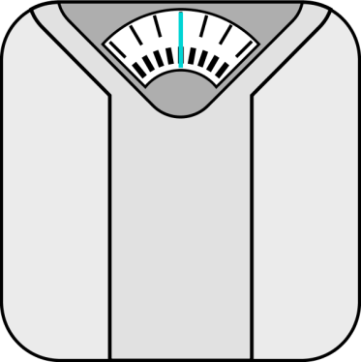

**SIX STEPS TO HEALTHY EATING**

1. Eat regular Meals
2. Try to cut down on the fat you eat, particularly saturated fat
3. Eat more fruit and vegetables
4. Cut down on Sugar
5. Use less salt. Avoid adding it to food at the table and use less in cooking
6. Drink alcohol in moderation (no more than 2 units a day for a woman and 3 for a man)

WEIGHT CONTROL

If you are overweight, losing weight is one of the most important things you can do. You will be able to discuss this with your dietician or GP.

If you are underweight, you may need extra calories. You could have this with scones, fruitcake, sandwiches, breadsticks or cheese and crackers

|  |  |
| --- | --- |
| **FOODS TO AVOID** | **USE INSTEAD** |
| Sugar – all types including; Brown Sugar, Glucose, Fructose, Sorbitol, Sucron | Artificial sweeteners such as; Sweetex, Candarel, Natrena, Hermesetas |
| Sweets, Chocolate and Mints |  |
| Ordinary squash, Pop, Lucozade or Sweetened Fruit Juice | Sugar free squash. Diet drinks, Low calorie drinks or Unsweetened fruit juice. |
| Jam, Honey, Maramalade, Treacle or Syrup | Reduced sugar Jam and Marmalade. Pure fruit spread. Marmite |
| Cakes and Biscuits | Occasional plain biscuits, such as; digestives, rich tea, ginger nuts, morning coffee and hobnobs. No more than 1 or 2 a day. |
| Tinned fruit in Syrup | Fresh fruit, stewed fruit without sugar, tinned fruit in water or fruit juice |
| Tinned and packet puddings. Jelly, yoghurt and mousses | Sugar free jelly, Diet yoghurt and fromage frais. Low sugar rice pudding and custard |
| Sugar coated breakfast cereal | Porridge, Bran flakes, Weetabix, Shredded wheat, sugar free muesli, fruit ‘n’ fibre |
| Milky drinks such as; Hot chocolate, Ovaltine or Horlicks | Reduced sugar Milky drinks such as; Highlights, Boots shapers, Options, Cocoa sweetened with artificial sweetener |

**Always be cautious of Portion Sizes!**

This is an average diagram of what your plate should look like. How much of each food groups you should be eating to maintain a healthy diet.

FRUIT AND VEG

BREAD, CEREALS, POTATOES, PASTA, RICE

MEAT+ FISH

Milk and Dairy foods

Fatty + Sugary foods